Requirement Analysis
Data Flow Diagram & User Stories
Date | 06-03-2026
Team ID | LTVIP2026TMIDS48993
Project Name | ToyCraft tales: tableau's vision into toy manufacturer data
Maximum Marks | 4 Marks

Data Flow Diagrams:
A Data Flow Diagram (DFD) is a traditional visual representation of the information flows within a system. A neat and clear DFD can depict the right amount of the system requirement graphically. It shows how data enters and leaves the system, what changes the information, and where data is stored.
DFD Level 0 :

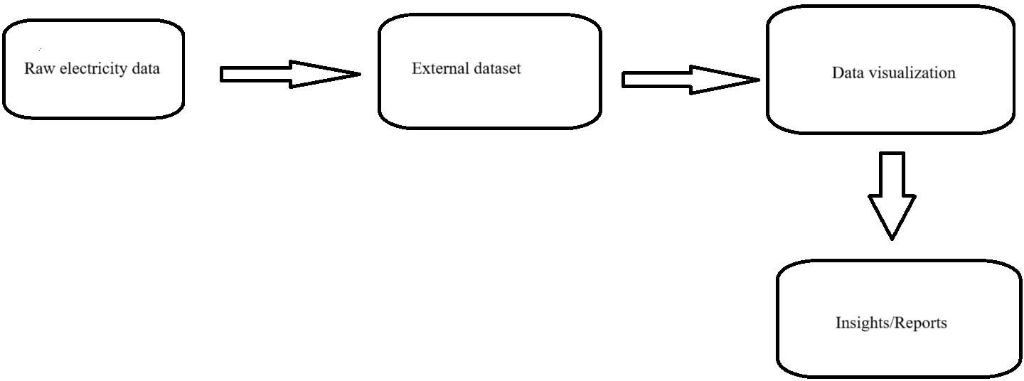

DFD Level 1 (industry level):

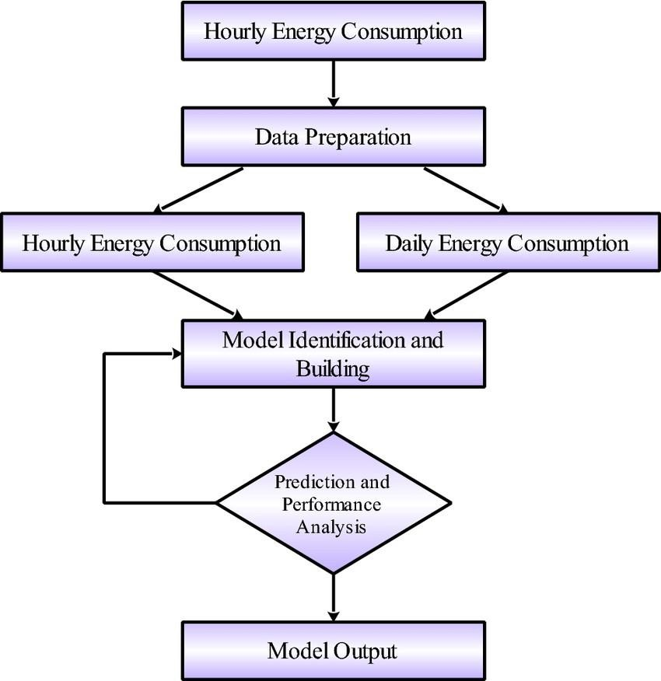

User Stories:

User Type | Functional Requirement (Epic) | User Story Number | User Story / Task | Acceptance Criteria | Priority | Release
Analyst / Researcher | Dashboard Access & Insights | USN-01 | As a user, I can explore electricity consumption across sectors and regions using an interactive dashboard. | Able to filter and view data on-demand | High | Sprint- 1
Power Utility Staff | Export & Reporting | USN-02 | As a utility manager, I can download consumption reports filtered by month and region. | Excel/PDF report  available | High | Sprint- 2
Policy Maker | Trend Forecasting | USN-03 | As a government user, I can identify peak usage trends and plan  accordingly. | Visual trendlines are displayed | Medium | Sprint- 2
Admin | Data Refresh | USN-04 | As an admin, I can upload new data files to refresh the dashboard. | System reflects updated values | High | Sprint- 1
Public Viewer | Access Summary Insights | USN-05 | As a general user, I can view key  highlights like topconsuming  sectors. | Summary cards/charts available | Medium | Sprint- 1

